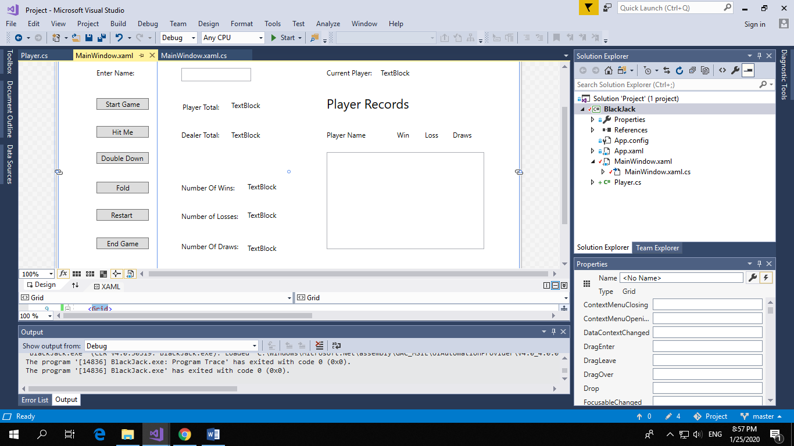

The idea of the game is blackjack. First you enter a name and press start game. If you get 21 at the beginning you get blackjack and win automatically otherwise you can choose to Hit me or double down if you go over 21 you automatically lose. You can choose too fold at any time if your below 21 then the dealer can try to beat whatever number you have if has 21 straight away and so do you it’s a draw otherwise if he gets 21 and you don’t you lose if he doesn’t beat you with his second card he can choose to hit if he’s under 21 and gets more cards he wins if he goes over you draw and if manages to get the same you lose. Once you have lost drawn or won your record will be recorder and shown in the list with other player records and added to a txt file. If you choose end game you move onto the next player.